Module 4: Functions and Goals of Financial Management 1
Lesson 2: Goals of Financial Management 1
Learning Objectives 1
Solvency Goals 2
Sources of Financial Information for Stakeholders 10
Financial Statements and Profitability 21

Module 4: Functions and Goals of Financial Management
Policyowners and beneficiaries depend on their insurer to meet its obligations when they come due. The insurer’s financial area has a large part of the responsibility of ensuring the company remains strong for its customers. In this module, we’ll discuss the variety of activities that take place in the financial management area and we’ll explore the financial management goals that are common to all insurers.
In this module, you’ll learn about
- The different aspects of an insurer’s financial operations, including accounting, financial reporting, treasury, investing, and auditing
- The goals of an insurer’s financial operations, including maintaining solvency, achieving profitability, and managing capital

Lesson 2: Goals of Financial Management
Learn about the goals of an insurer’s financial management functions, including maintaining solvency in order to meet financial obligations, providing information to stakeholders, managing the insurer’s capital, and achieving long-term profitability.

Learning Objectives

- Explain insurer solvency, and describe how an insurer can become insolvent.
- Describe tools insurance regulators use to monitor insurer solvency.
- Describe financial reporting requirements imposed by insurance regulators and securities regulators.
- Describe sources of information for external stakeholders other than financial reports.
- Describe the types of information included in an insurer's income statement and balance sheet.
- Show how the balance sheet relates to the basic accounting equation.
- Differentiate between profit and profitability, and discuss the relationship between capital management and long-term profitability.

Solvency Goals
Learning Objectives
Explain insurer solvency, and describe how an insurer can become insolvent.
Describe tools insurance regulators use to monitor insurer solvency.

Financial management is how an insurance company manages its resources to meet the company's financial goals. Which of the following are typical goals of an insurance company's financial managers? Choose all that apply.
- Providing financial information to stakeholders
- Maintaining assets that equal the insurer's liabilities
- Achieving financial compliance and stability
- Managing the company's solvency and profitability
- Managing capital and risk

Solvency vs. Insolvency
A top concern for insurance regulators is an insurer's ability to pay its obligations to customers as they come due.
Generally, regulators want to help insurers avoid insolvency, a situation in which the business is unable to meet its financial obligations on time. The opposite of insolvency is solvency—the ability to pay financial obligations on time.

Two situations can cause an insurer to be insolvent. First, the insurer might not have enough assets relative to its liabilities.
- Assets? Think "things of value"—like cash, financial securities, buildings, and land.
- Liabilities? Think "debts and obligations," including amounts that will be payable to customers.
Second, even though the insurer seems to have enough assets to cover its liabilities, the insurer might not have enough CASH to pay the amounts it owes NOW.
Imagine that a large number of policyowners surrender their policies at one time. The insurer might have enough assets but not enough "liquid" assets.
Liquid assets? Cash or other assets that are readily marketable for their underlying value.
Not all assets are liquid. Suppose an insurer owns a skyscraper valued at hundreds of millions of dollars. It can take months or years to find a buyer who is willing and able to buy the building and to complete the sale. Real estate is NOT a liquid asset.
When insurance regulators look at Forthright's financial situation, they want answers to a number of questions. Use the right arrows below to learn what they are.

The amount of funds Forthright thinks it needs to pay contractual benefits on products in force is a liability known as policy reserves. Requirements for adequate policy reserves help regulators make sure that insurers stay solvent.

The amount by which assets exceed liabilities is known as "capital," "capital and surplus," or "owners' equity." Owners' equity refers to the owners' stake in the company. Here, we'll refer to it as "capital."
Regulators require that insurers maintain certain minimum levels of capital. So, assets need to exceed liabilities by a comfortable margin.
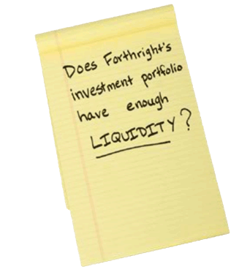
Having enough liquidity means that Forthright can meet a sudden, unexpected need for cash.

Regulations generally require insurers to invest the majority of the assets backing their obligations to customers in relatively safe, reliable securities. Insurers must also use specific rules when reporting the value of their invested assets.

Monitoring Solvency
Regulators use many tools to monitor insurer solvency. One example: financial reports that describe the insurer's financial condition and affairs. Insurers prepare these financial reports according to specified rules.
Regulators use these reports to evaluate an insurer's strength and flexibility. But regulators are not the only people who need information about Forthright. Employees, customers, and other stakeholders need it as well.
In the United States, the special report that insurers prepare for state insurance regulators is known as the Annual Statement.
Insurers must file this report with the NAIC (National Association of Insurance Commissioners) and with the insurance regulators in every state in which they do business.

Insurance laws in many jurisdictions require each insurer to undergo a financial condition examination—usually every 3 to 5 years. Examiners usually visit the insurer's offices and perform the examination on site.
A financial condition examination involves
- Examining accounting records to ensure that the insurer is operating on a sound and lawful basis
- Investigating the insurer's financial and business activities to ensure that they do not present any hazards to the insurer's solvency
- Producing an examination report, which identifies potential problems and recommends solutions to the problems
If a problem is uncovered during an examination, an insurer must respond in writing to the report, typically within 30 days. The response must specify how the insurer intends to correct any problems identified by the examiners.
Based on its findings in the financial condition examination, the insurance regulatory authority may take certain actions to protect the insurer's policyowners.

An investment portfolio that is heavily invested in real estate probably has a high degree of liquidity.
- True
- False
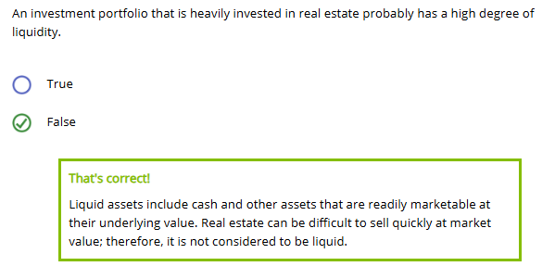
In the United States, insurers must file the Annual Statement with (Choose all that apply.)
- State insurance regulators in only the states in which the insurer does business
- Insurance regulators in all states, including states where the insurer does not conduct business
- The NAIC

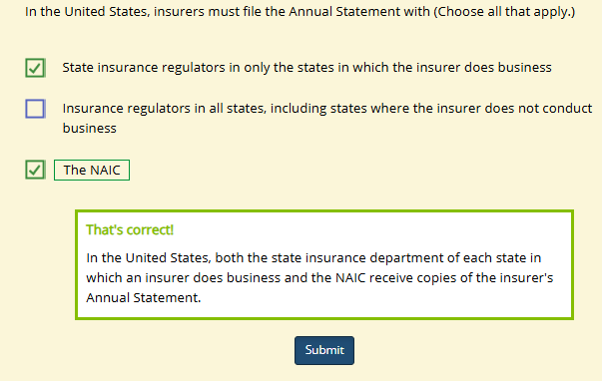
Which of the following statements about regulatory financial condition examinations are true? (Choose all that apply.)
- Insurers are usually required to undergo a financial condition examination every 3 to 5 years.
- Examiners cannot visit the insurer's offices during a financial condition examination.
- A financial condition examination involves an evaluation of the insurer's accounting records as well as the insurer's business practices.
- If a problem is uncovered in a U.S. financial condition examination, the insurer has 60 days to respond in writing to the report.

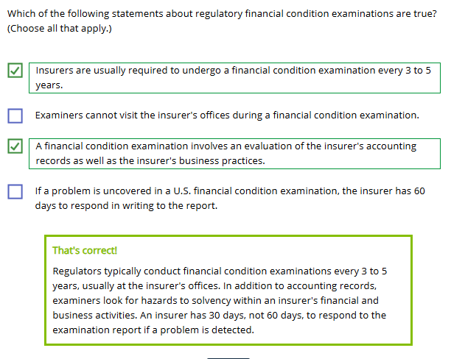

Sources of Financial Information for Stakeholders
Learning Objectives
Describe financial reporting requirements imposed by insurance regulators and securities regulators.
Describe sources of information for external stakeholders other than financial reports.
Insurance regulators primarily protect customers, who need to know that their insurer will be able to pay benefits when the time comes.
Other stakeholders—investors, creditors, financial professionals, and potential customers—also need a source they can trust for information. Sure, they want to know if the insurer can pay its bills. But they also want a broader evaluation of the insurer's performance as a business entity.
Securities regulators try to make sure these stakeholders get the information they need. In the United States, securities are regulated by two bodies:
- SEC—the Securities and Exchange Commission
- FINRA—the Financial Industry Regulatory Authority
Annual Report
One source external stakeholders rely on is a company's annual report—a financial report that securities regulators require companies to provide to their investors.
The SEC requires a U.S. insurer to publish an annual report for its stockholders and other interested parties if either of these is true:
- The insurer is a stock company, in which case its stock is a security and subject to securities regulation
- The insurer offers variable products, such as variable annuities or variable universal life insurance, which are securities and subject to securities regulation

Most insurers are stock insurers, and among the relatively few (though sometimes large) insurers that are mutual companies, most offer variable products, so most insurers are required to publish an annual report. Other insurers may prepare an annual report voluntarily.

Financial Audit Requirement

U.S. federal securities laws require publicly traded stock insurance companies to undergo annual external audits of their financial statements. Forthright is a stock company. So, every year, Forthright undergoes an external audit of its financial statements.
External auditors need access to an insurer's financial records, so they typically come to the insurer's offices to look more deeply into its financial records and operations.
Individuals performing the audit must
- Be employed by a public accounting firm
- Not be associated with the insurance company
What is the purpose of an external audit?
An external audit provides
- An independent professional opinion as to whether a company's financial statements fairly present the company's operations and that they were prepared according to a given set of accounting principles and standards
- Suggestions for changes to the company's system of internal control
- A report of audit findings

Sarbanes-Oxley Act (SOX)
The Sarbanes-Oxley Act (SOX) affects corporate governance and financial reporting for U.S. stock companies. Requirements of Sarbanes-Oxley include that
- A company's CEO and CFO must sign each financial statement and attest to the accuracy of the information contained in the statement
- External auditors are required to be independent to help avoid any potential conflict of interest
Annual Statement vs. Annual Report
We mentioned that Forthright, a U.S. insurer, prepares both an Annual Statement and an annual report. What's the difference?

Different audience. Different needs. Different accounting standards.

In the United States, the Annual Statement meets the specific requirements of insurance regulators, whose primary purpose is to safeguard insurer solvency. The information presented in the Annual Statement shows that an insurer can take care of its obligations to its customers, even if it stops doing business tomorrow.
The annual report, on the other hand, is a broad assessment of a company's financial performance. It assumes that the company will be in business going forward and helps users assess a company's profitability—its success in generating returns for its owners—as well as its financial strength. It is designed for external stakeholders with an interest in the company's financial performance.
The following table summarizes the differences between the Annual Statement and the annual report.
 | Annual Statement | Annual Report
Who must file or publish? | All insurance companies operating in the United States | Publicly traded stock companies  Companies that sell variable life insurance or variable annuity products
What is its purpose? | To demonstrate the insurer's solvency | To enable stockholders and investors to evaluate the insurer's profitability
Who is the audience? | • The National Association of Insurance Commissioners (NAIC)  • The insurance department in each state in which the insurer does business  • Financial professionals  • Policyowners  • Other interested parties | • Stockholders  • Potential investors  • Financial professionals  • Policyowners  • Other interested parties
Where Else Do Stakeholders Get Information?
Stakeholders can turn to a number of independent sources for financial information about an insurer, including
- Investment analysts
- Stock brokers and financial advisors
- Financial press and consumer advocates
- Rating agencies
How about insurance company employees? Not so fast…
An Ethical Dilemma

After attending a department meeting, Alan, an employee of Lakeview Insurance Company, composes this email to his wife, Jan.


Wait, Alan! Don't hit that SEND button yet!
What happens if Jan forwards this email to her boss at ABC Brokers?

What just happened here?
Alan didn't even realize he was treading in an ethical minefield, and yet he released inside information that is potentially damaging to his company.
This is just one example of how a small careless action can have big consequences for a company.
Rating Agencies
Many people turn to rating agencies for information about insurers. That's why it's important for Forthright to maintain or improve its rating.

Rating agencies provide standardized ratings that indicate an insurance company's
- Financial strength and financial flexibility
- Ability to pay its obligations to customers
- Ability to pay its obligations to creditors
The rating assigned to a company allows external parties to compare different insurers on a standard basis…that is, apples to apples.
When a rating agency develops or reviews an insurer's financial rating, it does more than look at financial statements. It performs a comprehensive review of an insurer's financial affairs and prospects.
Rating agencies usually rate insurers on a modified alphabetical scale. The highest rating is something like AAA or A++, and the lowest rating is something like D, E, or F, depending on the agency.
Use the right arrow to learn why various stakeholders are interested in an insurer's ratings.

Financial professionals: Which insurers should I recommend to my clients?

Of the following insurers operating in the United States, select those that are required by the SEC to publish an annual report.
☐ The Stargazer Insurance Company is a stock company that sells only guaranteed products such as whole life and fixed annuities.
☐ The Triangle Insurance Company is a mutual company that sells both fixed and variable insurance products.
☐ The Horizon Insurance Company is a mutual company that sells only guaranteed products such as whole life and fixed annuities.
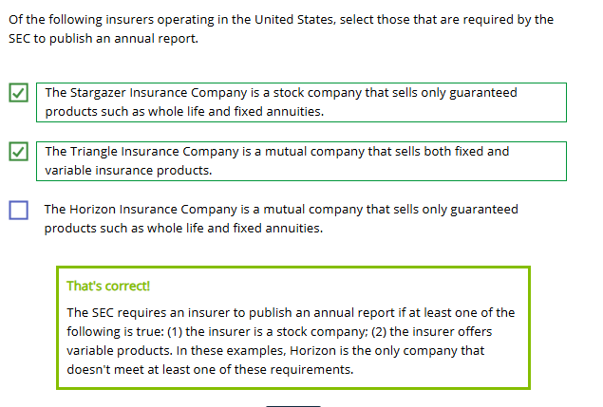
External audits are performed primarily for the benefit of company management.
- True
- False
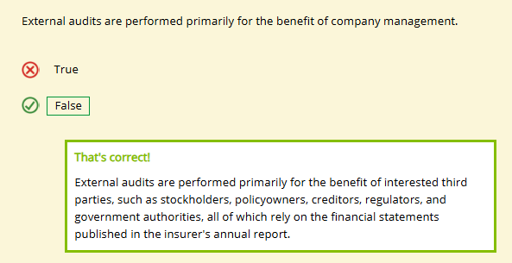
Correct statements about the U.S. Annual Statement and the annual report include that an insurer files the (Annual Statement / annual report) with state insurance regulators and the NAIC. In addition, the (Annual Statement / annual report) aims to show that the insurer could meet its obligations to customers even if it ceased doing business.
○ Annual Statement / Annual Statement
○ Annual Statement / annual report
○ annual report / Annual Statement
○ annual report / annual report
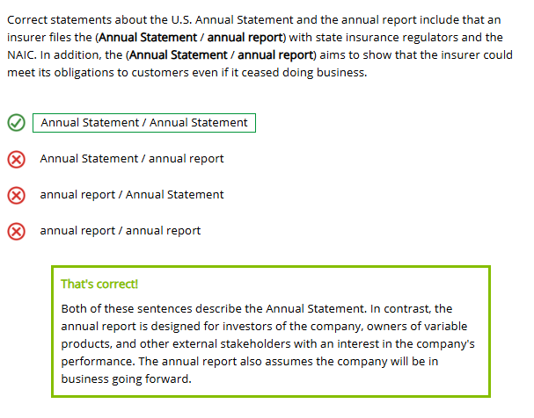
The primary role of a rating agency is to evaluate whether an insurer's financial statements were properly prepared.
- True
- False
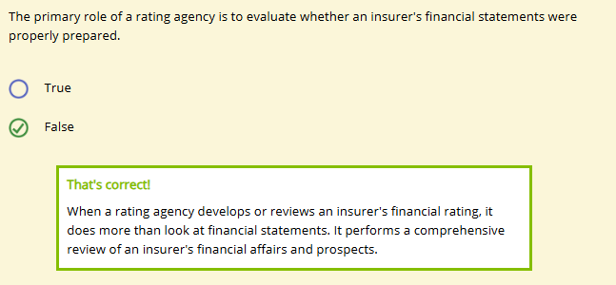

Financial Statements and Profitability
Learning Objectives
Describe the types of information included in an insurer's income statement and balance sheet.
Show how the balance sheet relates to the basic accounting equation.
Clearly, one of Forthright's most important financial management responsibilities is preparing financial statements. Forthright does this to comply with regulations and provide information to stakeholders.
But what, exactly, is a financial statement? Let's find out.
All of a company's financial transactions enter its accounting system, which records the flow of funds into and out of the organization. The system categorizes and summarizes the information in each transaction and creates financial statements. This figure illustrates the process.
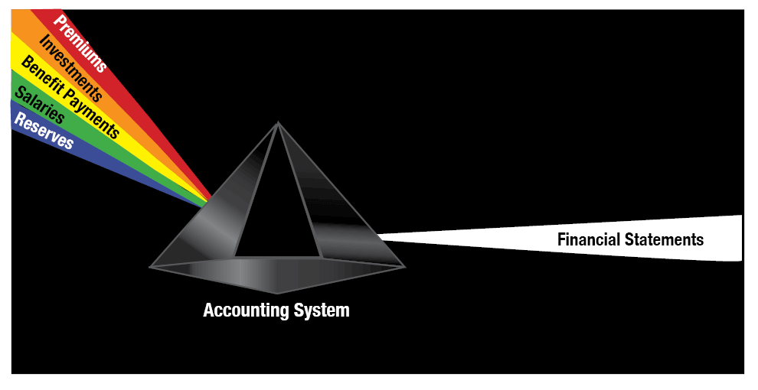
Income Statement
There are several types of financial statements. First is the income statement. What does it show Forthright?
Revenues: Amounts that Forthright earns from its business operations.
Expenses: Amounts that a company spends to support its operations.
The figure illustrates typical revenues flowing in and expenses flowing out of an insurer.


In general, what do you think is an insurer's most significant source of revenue?
- ⭘ Revenue from products
- ⭘ Earnings from investments
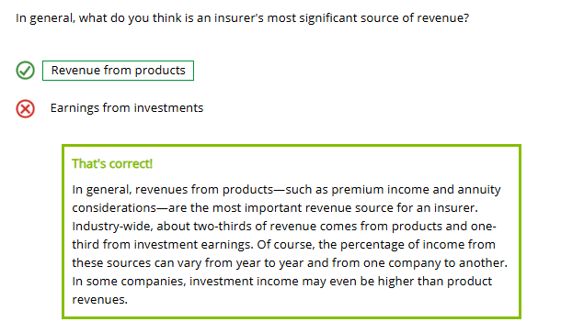
What do you think is an insurer's greatest expense?
- ⭘ Benefit payments to customers
- ⭘ Operating expenses
- ⭘ Taxes

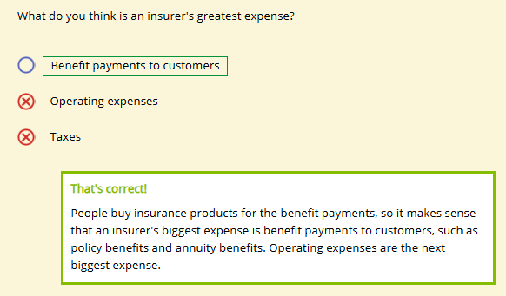
How Can I Tell If a Company Made a Profit?
When an insurer subtracts its total expenses from its total revenues, the result is either net income (profit) or a net loss.
Click or touch in the boxes below to learn more about both of these.
Net Income
If total revenues > total expenses, then the result is net income, or profit.

$600 million (total revenues) – $590 million (total expenses) = $10 million (net income or profit)

Net Loss
If total expenses > total revenues, the result is a net loss.

$580 million (total revenues) – $590 million (total expenses) =
-$10 million (net loss)

The Balance Sheet
The other major financial statement is the balance sheet. Whereas the income statement shows how well the company performed over a specific period, the balance sheet is a snapshot of the company's financial condition at a specific point in time. The balance sheet lists the values of a company's assets, liabilities, and owners' equity as of a specific date and is based on the basic accounting equation:
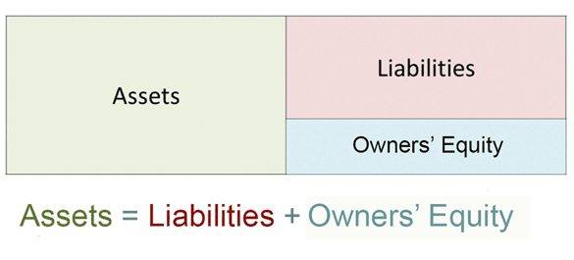
As a reminder, assets are things of value owned by a company. Liabilities are a company's debts and future obligations. Owners' equity is the amount remaining after liabilities are subtracted from assets, which represents the owners' investment in the company.
Note: Insurers usually refer to owners' equity as capital and surplus. In this lesson, we use "capital" to refer to both "capital" and "surplus." Substituting "capital" in place of "owners' equity" in the accounting equation results in


Can you identify the most important asset category for insurers?
- ⭘ Cash
- ⭘ Securities
- ⭘ Buildings
- ⭘ Furniture
- ⭘ Land
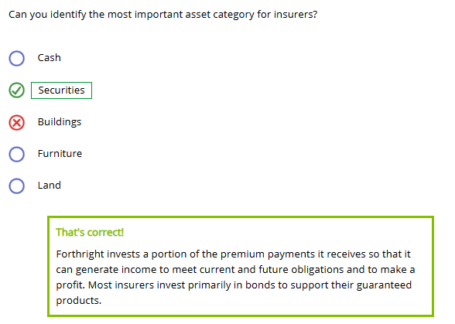
What do you think Forthright's largest liability is?
- ⭘ The mortgage on its office building
- ⭘ Accounts payable to suppliers
- ⭘ Policy reserves

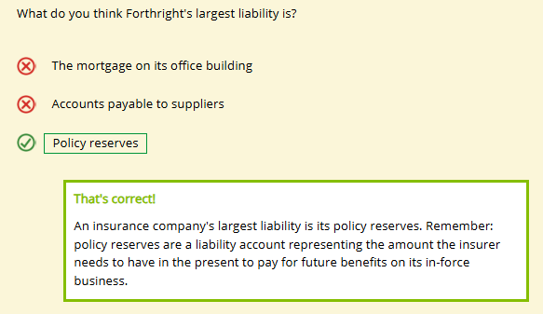
When an insurer calculates its policy reserves, it takes into account that it will receive premiums and interest earnings in the future that can also be used to help pay policy benefits.
The balance sheet takes its form from the basic accounting equation, and gets its name from the fact that it is always in balance: the amount of assets ALWAYS equals the amount of liabilities plus capital. If assets increase and liabilities decrease, then capital increases. If assets decrease and liabilities increase, then capital decreases. The following video illustrates this process.

On an insurer's income statement, examples of typical expenses would be
- ⭘ Investment income and annuity benefits
- ⭘ Premium income and operating expenses
- ⭘ Annuity benefits and policy benefits
- ⭘ Annuity considerations and operating expenses
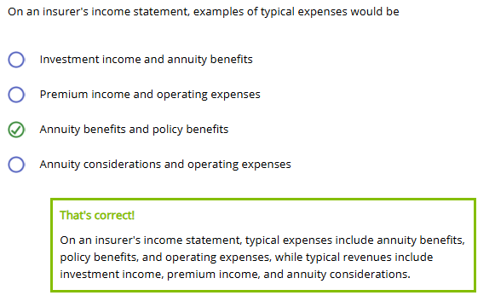

On December 31, the Foundry Insurance Company has $25 billion in assets and $20 billion in liabilities. According to the basic accounting equation, this means that Foundry's capital (owners' equity) as of December 31 was equal to
- ⭘ -$5 billion
- ⭘ $5 billion
- ⭘ $25 billion
- ⭘ $45 billion

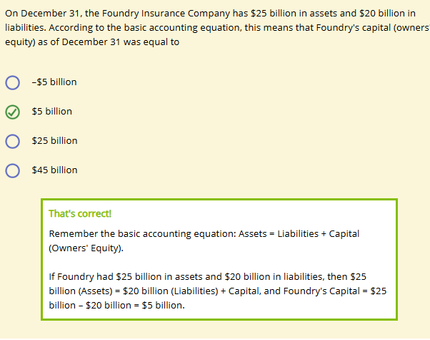

Profitability and Capital Management
Learning Objectives
Differentiate between profit and profitability, and discuss the relationship between capital management and long-term profitability.

Which do you think is a more accurate measure of overall success?
- Profit
- Profitability


Profit vs. Profitability
Net income or net loss, as we saw on the income statement, is the difference between revenue and expenses during a particular time period—such as a month, a quarter, or a year. So, the income statement measures financial success (or failure) during a relatively short period of time.
Profitability is a broader measure of financial success that stretches across many accounting periods of profit and/or loss.
Profitability refers to a company's ability to generate profit and its ability to increase the wealth—or value—of the business over time. Steady, long-term profitability results in a steady increase in the insurer's owners' equity—its "capital."
The following video illustrates how profitability increases an insurer's capital.

Capital Management

The benefits of a strong capital position can include
- A greater ability to withstand difficult conditions, such as a bad economy
- Better ratings from rating agencies
- A greater ability to attract more business
- An increase in the "value" of the company (for example, stock price)
- A strong solvency position
- Greater flexibility for the company
- A greater ability to raise capital on favorable terms
- Potential brand enhancement
- A symbolic measure of confidence for current or potential business partners, employees, and customers
On the other hand, remember that a company needs to take a risk to earn a return. A company can have too much capital: by not taking sufficient risk with its capital, it may not earn a satisfactory return.
A company's continued profitability requires monitoring current capital management strategies and updating these strategies as circumstances change. Sometimes those strategies may call for raising capital and sometimes they might call for deploying—that is, using or investing—some of its capital. Click or touch each heading below to learn more about these strategies.
Raising Capital
As we've seen, insurers can add to their capital through long-term profitable operations. However, sometimes insurers need to raise capital more quickly.
Some ways that an insurer can raise capital include
- Issuing new shares of stock
- Borrowing/issuing debt securities
- Reinsuring part of its business
- Selling part of its business

Deploying Capital
Other times, insurers need to decide whether and how to spend capital.

Can you think of ways that Forthright could deploy its capital? Did you think of these?
- Building new products, product lines, or distribution channels
- Investing capital in stocks, bonds, real estate, or other investments
- Buying back shares of its own stock to increase the value of its remaining stock
- Expanding into new states, provinces, or countries
- Paying policy dividends on participating policies, making policyowners more inclined to keep their policies in force
- Paying dividends to stockholders to increase the attractiveness of the company's stock to investors
- Paying off debt
- Acquiring another company
- Acquiring in-force policies from another company

Capital Management and Risk
Capital management involves high-level, strategic decisions that require input from the highest executives, including the CEO, CFO, and board of directors.
So, when companies decide to deploy capital, they choose the option that will provide the highest return on capital, right?
Not quite. Return is part of it. But there's another issue…
…Risk!
Recall from our ERM discussion that the insurer must consider not only the potential return of the investment, but also the risk of the investment, and whether the return justifies taking the risk.
Just because a capital investment is expected to earn its required rate of return, doesn't mean that we'll make that investment. Our stakeholders expect us to maintain a relatively low risk profile to safeguard our customers' funds.

The insurer considers how the investment fits with its overall risk profile. Remember, ERM requires the insurer to take a company-wide view of risk and coordinate the risks it faces across the enterprise.

If Foundry increases its assets and decreases its liabilities, then Foundry's capital will increase.
- ⭘ True
- ⭘ False
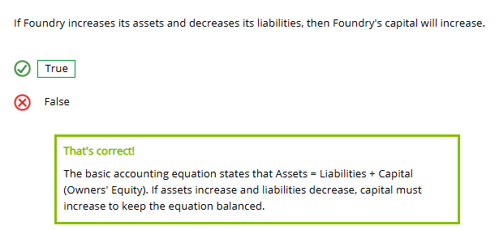
An insurer's capital management strategies can involve deploying capital or raising capital. For an insurer, one example of deploying capital would be
- ⭘ Issuing new shares of stock
- ⭘ Reinsuring part of its business
- ⭘ Selling part of its business
- ⭘ Acquiring another company

